Amazon Company Choices
Student’s Name
Institution Affiliation

Amazon Company Choices
Introduction
Amazon is the US-based technology company that is known for artificial intelligence, e-commerce, and cloud computing as well as digital streaming. Amazon sells a variety of products such as books, movies, toys, and electronics online (Amazon.com., 2019). Amazon was created in 1994 by Jeff Bezos who was the former Wall Street executive. When it was created, Amazon used to purely sell electronic books in an online store. The idea behind the creation of Amazon was to enable anyone around the world to buy a book online (Amazon.com., 2019). The creation of the name Amazon was done using the first letter in the alphabet and having an association with the South America River. The mission statement of Amazon states that Amazon Company exists to serve its customers online and in physical stores by prioritizing convenience, price, and selection. According to (Hall, 2019) many people were adamant about the idea of selling merchandise online. However, Bezos believed that if any company wanted to gain a competitive advantage in online marketing, that company needs to get Big Fast (Hall, 2019). Therefore, Bezos decided to put down strategies that will see Amazon “get big fast.”
Milestones of Amazon
The Company attained $15.7 million in revenue with 180000 customers in Dec. 1996.
Attained $ 148 million in revenue with 1000000 customers in Oct. 1997
Started Selling more than books and holding inventory in warehouses in 1997
Started selling music in 1998
The New York Times named Bezos “Person of the Year” after the creation of a patent on the “1-click checkout” in 1999.
Started selling clothing in 2002
Started online marketing and also other companies for a larger profit in 2003
Amazon entered China in 2004.
Initiated Prime Membership program for $79 a year in 2005.
2007- Amazon purchased Kiva systems to facilitate quick order fill in 2007 and also established New Headquarters in Seattle during the same year.
Benzo created a larger profit for the paper in 2012
The company began delivering packages on Sunday’s in 2012
The company Launched “Fire Phone” which was its first and last phone in 2014
Benzo organized purchased the social video game called, “Twitch” in 2014
The company launched its first physical bookstore in Seattle Washington
The company acquired the smart speaker in 3,000 stores called, Echo” in the end of 2015
The company used $13.7 billion to acquire 471 Whole Food stores in 2017
Started running advertisements for the location of the second headquarter in the end of 2017
The company Reached $1 trillion in revenue in 2018 and it also announced that its second headquarters will be located in Virginia Arlington and New York.

Data
The major profits of Amazon Company come from its online store. However, there are other services such as digital subscriptions, sales from the third party, and Amazon Web Services that generate huge profits for the company. As of 2018, the net revenue of Amazon Company was estimated to be 232.89 billion. It’s reported that 50% of this revenue was generated from the sale of retail products, electronics, and multi-media (Dollars, 2019). Since it was started, Amazon Company has shown consistent growth in its revenue numbers and also the number of its employees. For example, in 2007, Amazon had a total of 1700 employees while in 2018, the number went up to 647500 (Amazon.com., 2019). The increasing number shows that the company is growing. The employees are located in the fulfillment centers, distribution centers, and warehouses in the U.S.

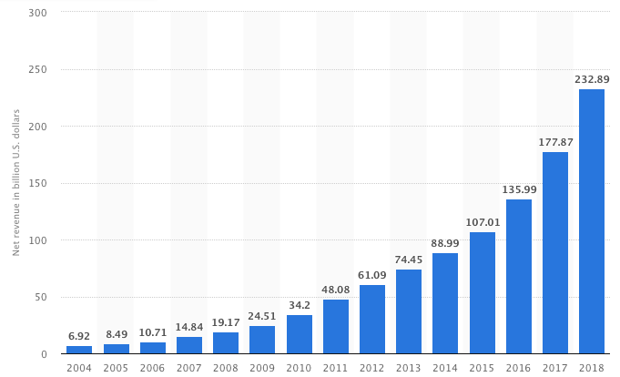

Figure 1. Net Sales revenue of Amazon from 2004 to 2018 (in billion U.S. dollars). Adapted from “The Statistics Portal” by N. Dollars. Retrieved March 6, 2019, from https://www.statista.com/statistics/266282/annual-net-revenue-of-amazoncom/. Copyright 2019 by Statista.

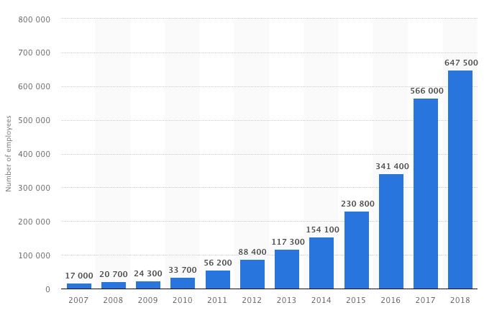

Figure 2. Number of Amazon.com employees from 2007 to 2018. Adapted from “The Statistics Portal” by N. Dollars. Retrieved March 6, 2019, from https://www.statista.com/statistics/234488/number-of-amazon-employees/. Copyright 2019 by Statista.
Analysis
Over the years, Amazon Company is believed to be having a corporate culture that encourages innovativeness and taking risks among its employees. Amazon has been able to dominate the online retail market through the innovations that have happened by taking risks. According to (Dollars, 2019)Amazon Company has been able to seek new opportunities on how data-intensive processes can be intensively utilized to facilitate smooth online retail services that the company is majoring in. The organizational culture of Amazon Company is characterized by a peculiarity which emphasizes on trying new things, boldness which emphasizes in taking risks and customer-centricity that prioritizes customers.
Through Amazon’s organizational culture, Amazon employees are well empowered to find necessary solutions for the business problems that they are facing in the company and improve the company’s online business. Amazon Company is continuously striving to satisfy the needs of its customers. This is why the employees in the company are encouraged to focus on the innovation of new ideas that will lead to satisfaction of the needs of the customers (Meyer, 2017).
By deciding on going online and prioritizing the needs of the customers, Amazon Company has ripped huge benefits. For example, the company has been able to grow its revenue at a higher rate throughout the years as shown in the figure below. The revenue of the company has been increasing steadily since 2014 because the company has been able to reach many customers through its online business.
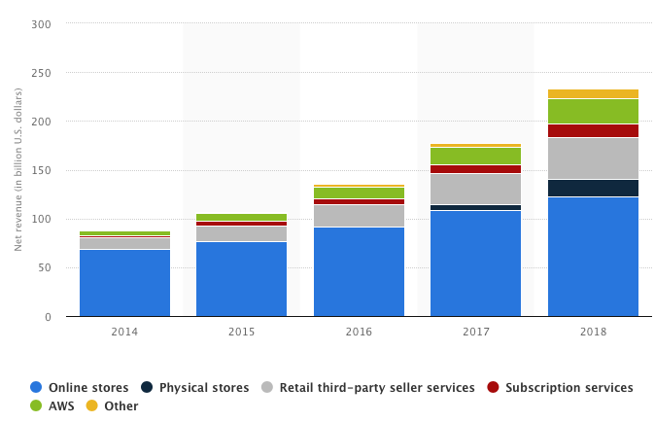

Figure 3. Global net revenue of Amazon.com from 2014 to 2018, by product groups (in billion U.S. dollars). Adapted from “The Statistics Portal” by N. Dollars. Retrieved March 6, 2019, from https://www.statista.com/statistics/672747/amazons-consolidated-net-revenue-by-segment/. Copyright 2019 by Statista
However, the success that the company has realized through its online business has come at a great cost. This is so because the company has invested a lot in its online business. For example, Amazon was taken to court by Toys R Us for failing to honor their agreement of making this Toy store the sole toy seller in Amazon.com. The owner of Toys R Us won the case in 2006 and Amazon was ordered to discontinue the partnership (Dollars, 2019). This ruling negatively affected Amazon Company’s image. It’s believed that this is the reason that Amazon Company lost more than $ 10 billion in 2019 when the Pentagon decided to award the highly contested contract to Microsoft.

Conclusion
Amazon Company is by far one of the risk-takers. This is so because to perform at high levels as they are doing now, the company took the high risk of creating a huge transition in its business plan. Jeff Bezos who is the CEO and the founder of the company had to adjust from selling books only to selling large selections of products. The company has been able to constantly provide a large selection of its products while at the same time keeping the focus on the needs of their customers. Amazon Company has been able to create a shift in the online shopping world. The company has changed the way people sell and buy products as well as the way people communicate. Even though the company has faced various challenges, for example, the company reputation was destroyed due to lawsuits filed against the company as a result of stiff competition online the diversity within Amazon has created its large stock market cap enabling the company to generate high revenue every year. This, therefore, justifies the decision the company made to go online and introduce a variety of products. To improve their online.

References
Amazon.com. (2019). Amazon’s Mission Statement. Retrieved from: https://www.amazon.com/Mission-Statement/dp/B00LU91Y32.
Dollars, N. (2019). Amazon: annual revenue 2017 | Statista. [online] Statista. Retrieved from: : https://www.statista.com/statistics/266282/annual-net-revenue-of-amazoncom/.
Hall, Mark (2019) Britannica. Amazon.com American Company. Retrieved from https://www.britannica.com/topic/Amazoncom.
Meyer, P. (2017). Panmore Institute. Amazon.com Inc.'s Organizational Culture Characteristics (An Analysis). Retrieved from: http://panmore.com/amazon-com-inc-organizational-culture-characteristics-analysis.

